Learning Outcomes

1. Understanding Windows Azure
2. Running the Sample To-Do app from Azure

Windows Azure

Microsoft Azure is a growing collection of integrated cloud services—analytics, computing, database, mobile, networking, storage, and web—for moving faster, achieving more, and saving money.

1. Signup and Login to your Azure account (https://azure.microsoft.com)

Use the link below to get 25$ azure credits monthly for a year.

<https://www.visualstudio.com/en-us/products/visual-studio-dev-essentials-vs.aspx>

1. Vision College has some student accounts that we can use for practice.

Access the Azure Portal (https://portal.azure.com/)

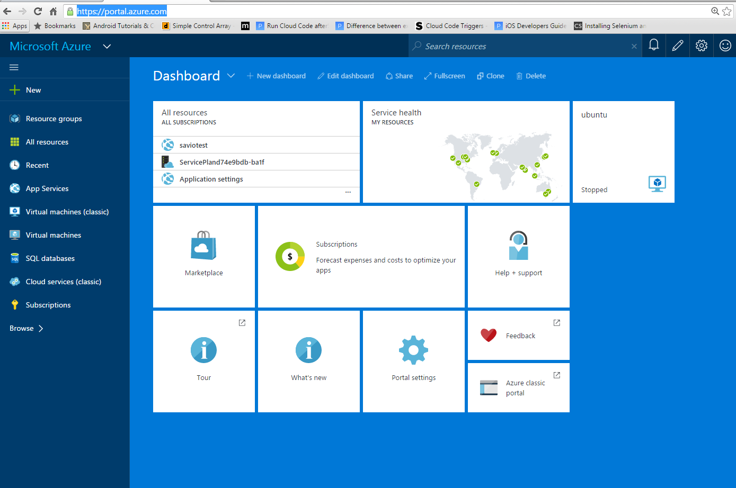

1. Creating a SQL Server database on Azure

Click on New -> Data +Storage -> SQL Database

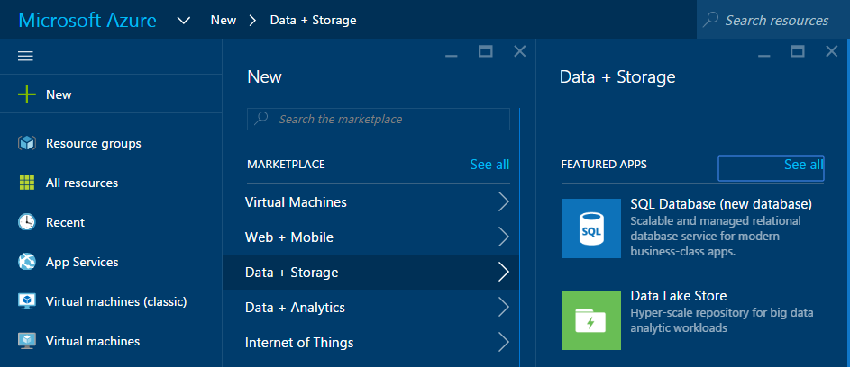

Next you need to setup the settings for SQL database and the server

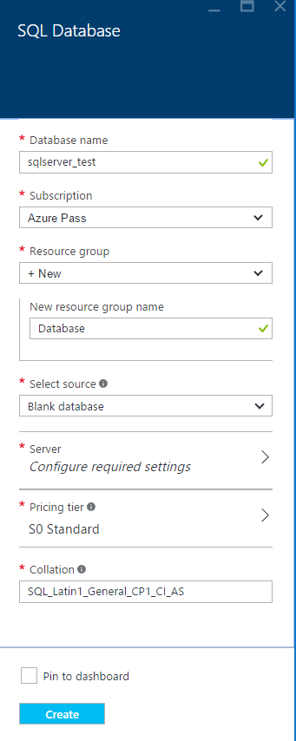 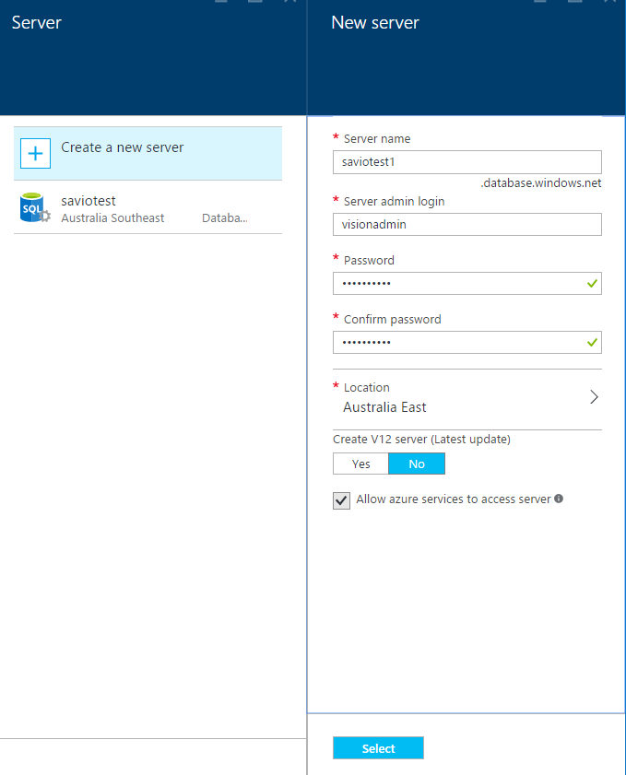

Pricing tier (Select the cheapest so that you do not exceed your credit limit)

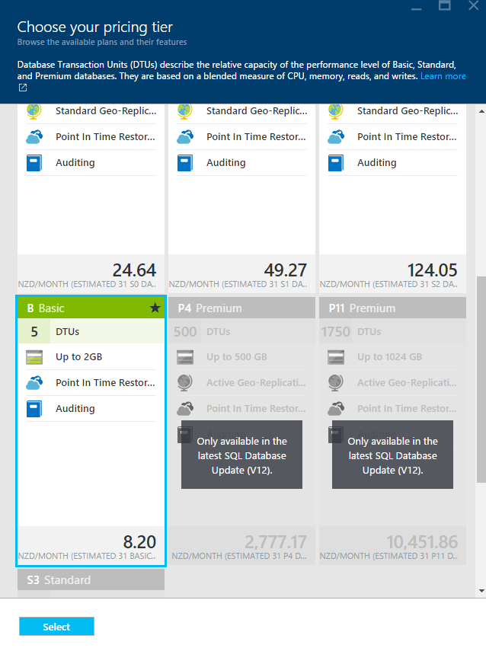

Select and then create your database server

Under all resources you can see your SQL server





Click on your SQL server

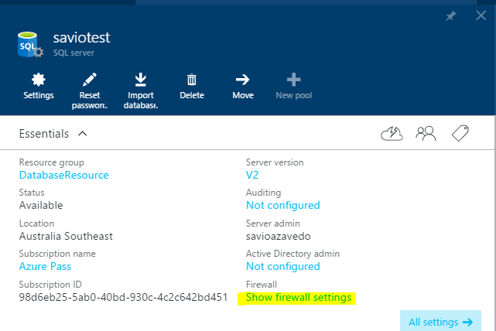

And access your firewall settings (This is important since you only allow computers with these IP addresses to access your server)

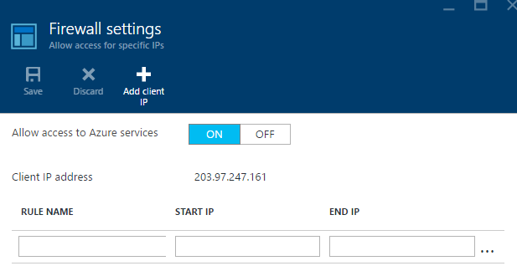

Click on Add client IP to open to add your computer to access the database.

Next click on your database (you will find a server name and connection strings)

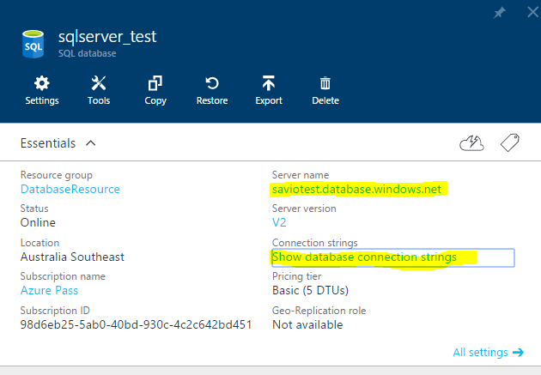

Go to your SQL Server Management System

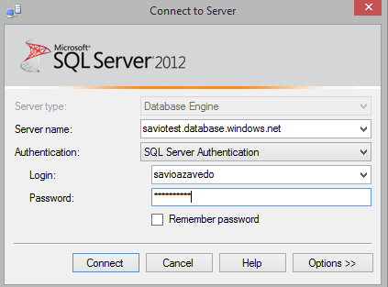

Enter the server name, login and password and click connect

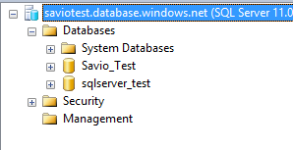

Now under your server you can find your databases.

Try to move your Hamilton library project or your Video Store Project onto Azure.

1. Creating a mobile app using azure app service

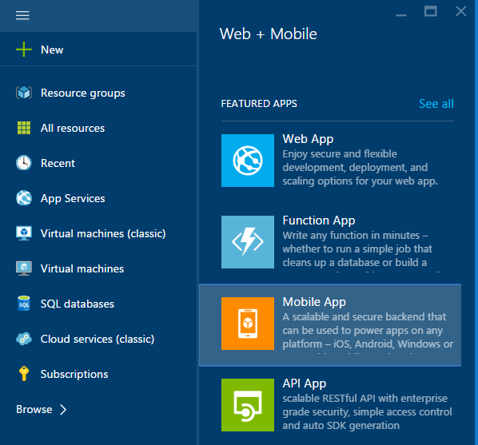

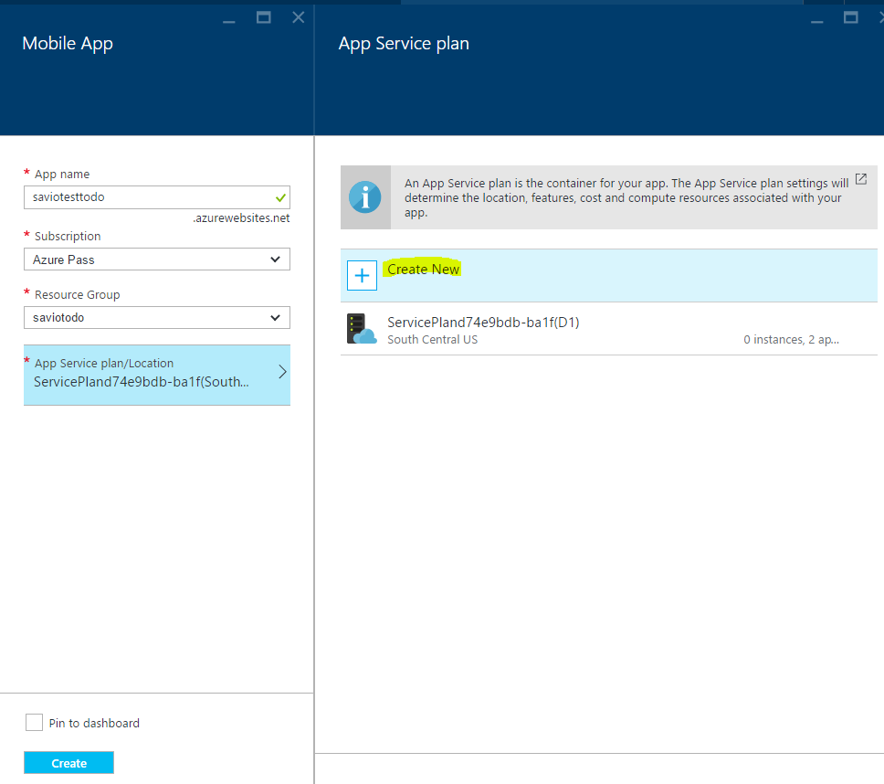

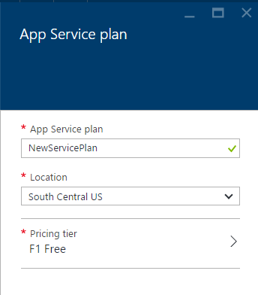

Under all resources, now you can see the newly created App Service



Click on it to open up the screen below

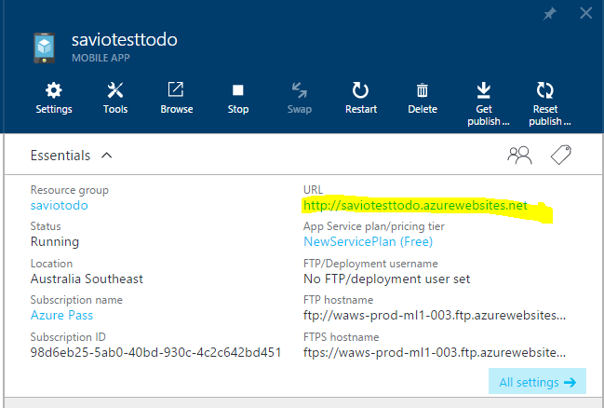

Click on All Settings and under settings click on quick start

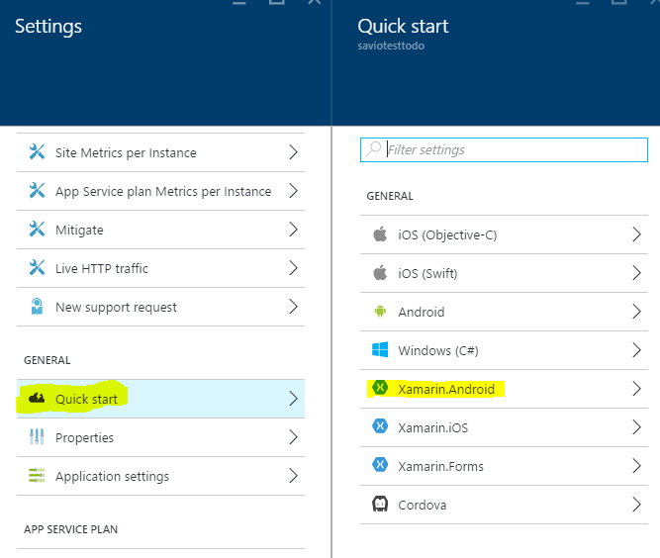

Select Xamarin.Android

Connect a database that you have already created.

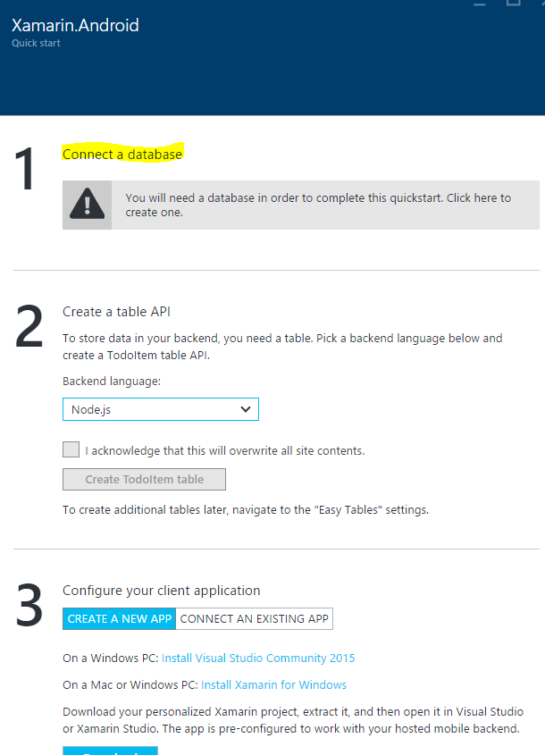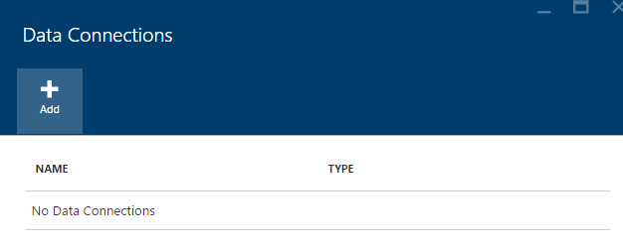

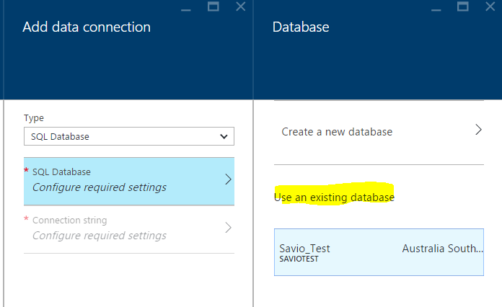

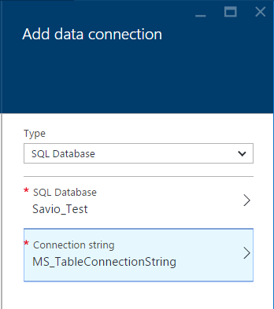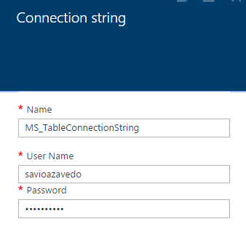

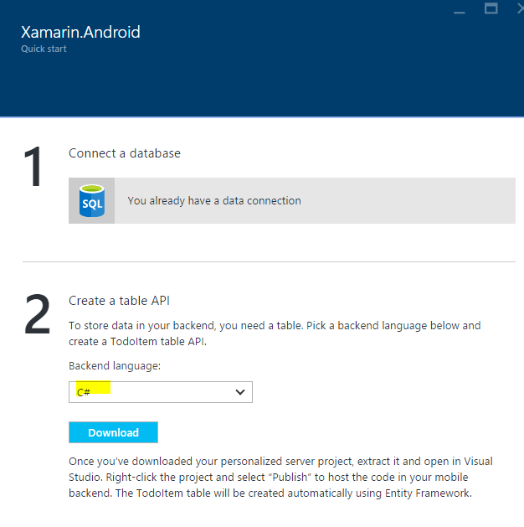

Select C# as the backend language and download the project.

Unzip and open the downloaded solution

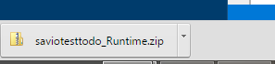

Open up the solution

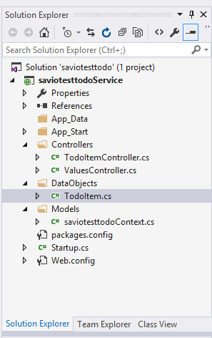

Clean Solution and then Rebuild (that should resolve the nu-get package errors)

Right click on your project solution -> Click publish

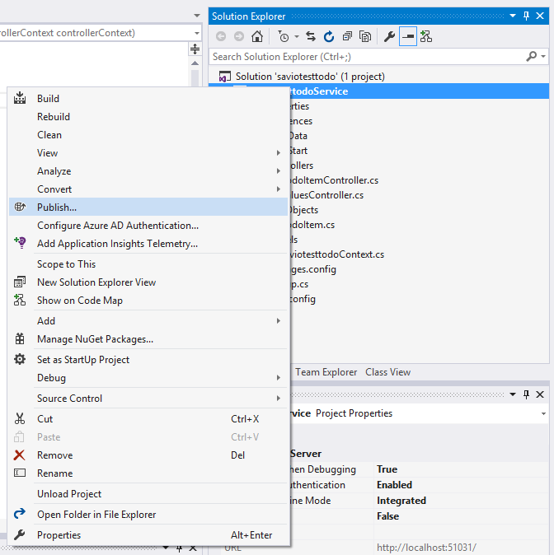

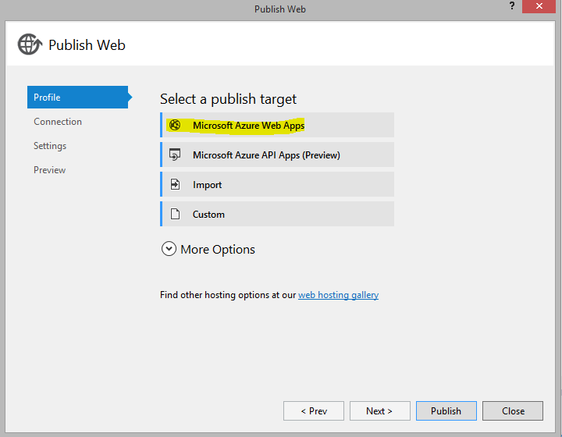

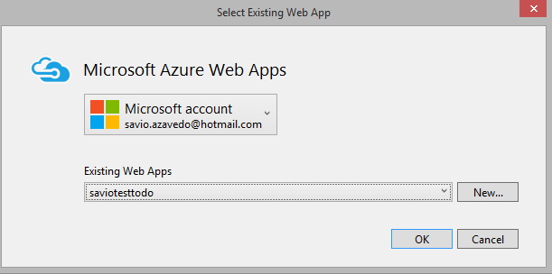

And click ok

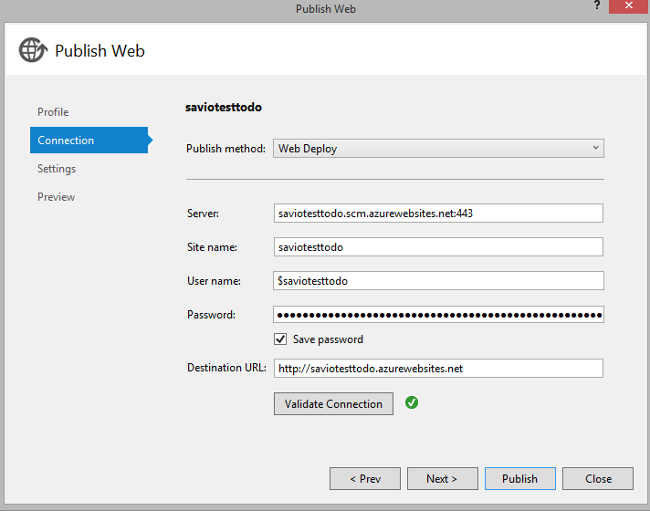

Next step is to download the mobile app

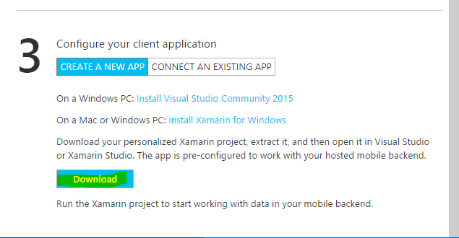

Clean the Solution and Rebuild it.

Run the app

Add some to-do Items

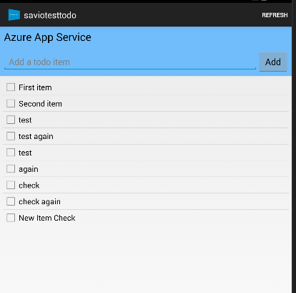

Go back to your SqlServer database and check the added records

